**San Francisco State University**

**CSC 648 - 848**

**Milestone 0 Submission Form**

**Section 4 Team 3**

Below is a list of the technologies used in Team's software stack:

* Server host: AWS EC2 t2.micro 1vCPU 1GB RAM
* Operating System: Ubuntu 22.04 Server LTS
* Remote database: AWS RDS MySQL v8.0.28, 1vCPU 1GB RAM
* Web framework: Django 4.1
* Server-Side Language: Python 3.11.1

Additional Technologies:

* IAM (Identity Access Management): Used for creating login users
* Route53: Used for creating a hosted zone for domains + domain name registration
* AWS Certificate Manager: Used for requesting SSL Certificates
* Application Load Balancer: Easy traffic distribution and HTTPS SSL termination

| Item | Credentials |
| --- | --- |
| Website URL | <https://csc648-04-sp23-team03.com/about/> |
| AWS Sign-in URL: | <https://750675026084.signin.aws.amazon.com/console> |
| EC2 Access:   1. Provided email with login instructions for my AWS Console.    1. Prof Username: hjsonghjsong    2. TA Username: nassim    3. Please check the email for the password 2. Go to: [Dashboard | EC2 Management Console (amazon.com)](https://us-west-2.console.aws.amazon.com/ec2/home?region=us-west-2#Home:) 3. Click on  **i-0167a6c2d9a198f9d (raul-webserver-test)** 4. Click “Connect” on the top 5. It should take you to URL: [Connect to instance | EC2 Management Console (amazon.com)](https://us-west-2.console.aws.amazon.com/ec2/home?region=us-west-2#ConnectToInstance:instanceId=i-0167a6c2d9a198f9d) 6. Leave username as ubuntu 7. Click connect and it will start a web browser shell session on our root server | |
|
|
| Database URL | raul-db-test.cmni1wwhpysg.us-west-2.rds.amazonaws.com |
| Database Username | admin |
| Database Password | 648Admin~!Z |
| From the EC2 Instance: Run this command:  “mysql -h raul-db-test.cmni1wwhpysg.us-west-2.rds.amazonaws.com -P 3306 -u admin -p”  copy/paste the password | |

|  | AWS | Python | Django | MySQL | Application Load Balancer | Jira |
| --- | --- | --- | --- | --- | --- | --- |
| Raul | 5 | 3 | 1 | 3 | 5 | 5 |
| Andy | 1 | 2 | 1 | 2 | 1 | 1 |
| Fred | 1 | 2 | 1 | 2 | 1 | 1 |
| Dean | 1 | 1 | 1 | 2.5 | 1 | 1 |
| Jonathan | 1 | 1.5 | 1 | 2 | 1 | 1 |
| David | 1 | 2 | 1 | 2.5 | 1 | 1 |

Based on our familiarity, we setup the following study plan. We are all responsible for learning the framework and backend to better understand how the core app operates.

* AWS:
  + Fred (Backend)
  + Andy(Github Master)
  + David (Scrum Master)
  + Andy (Github Master)
  + Jonathan (Front end)
* Django:
  + Fred (Backend)
  + Andy(Github Master)
  + David (Database)
  + Dean (Scrum Master)
  + Jonathan (Front end)
  + Raul (team lead)
* Python
  + Fred (Backend)
  + Andy(Github Master)
  + David (Database)
  + Dean (Scrum Master)
  + Jonathan (Front end)
  + Raul (team lead)
* MySQL:
  + Raul (team lead)
  + David (Database)
* Jira
  + Dean (Scrum Master)
* Application Load Balancer:
  + Raul (team lead)
  + Jonathan (Front end)

Addtional technologies were touched upon but not a priority..

Screenshots:

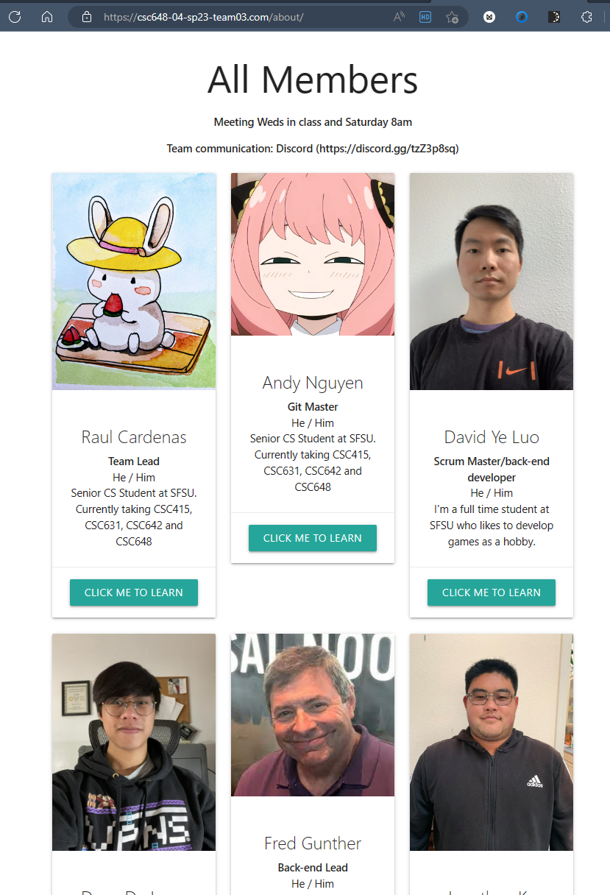

Each member is pulled from the database using primary keys as seen in the application django index.html/detail.html code when a button “CLICK ME TO LEARN” is pressed:

